
Touchstones Project
Netcards

Play Netcards with Text

Adult’s Playing HRJ
Animals at Play HRJ
Balance HRJ
Beach HRJ

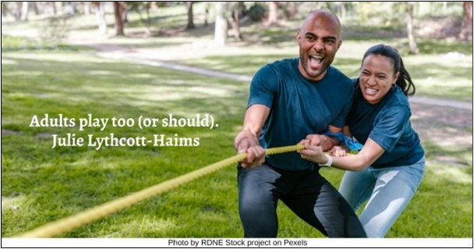

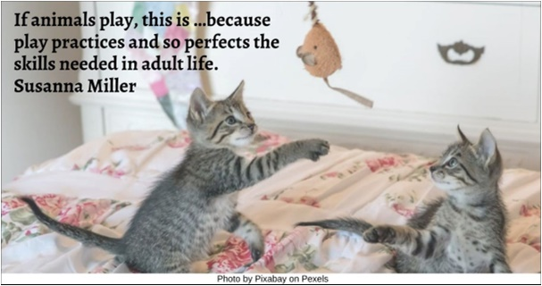

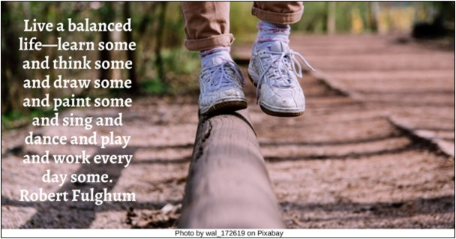

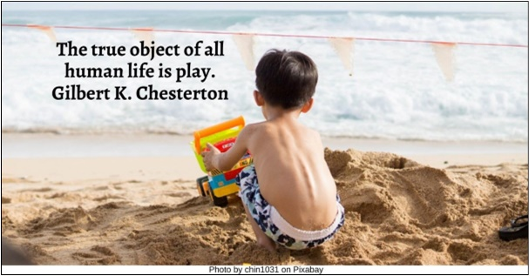

Blowing Bubbles HRJ
Broken Toy HRJ
Child Playing HRJ
Children Looking at Clouds HRJ

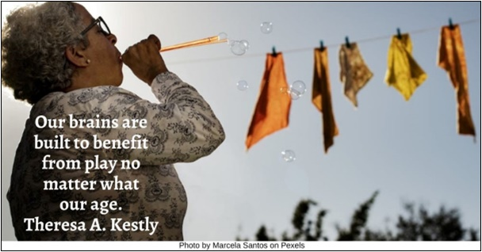

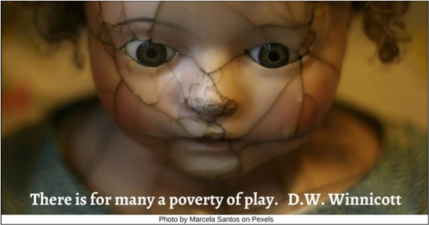

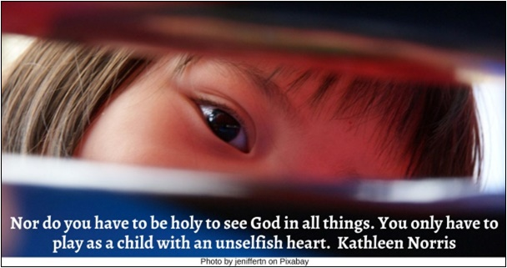

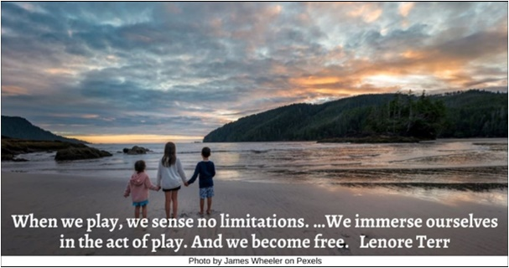

Clown HRJ
Concentration HRJ
Daydreaming HRJ
Father Playing HRJ

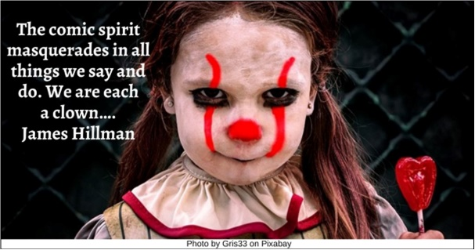

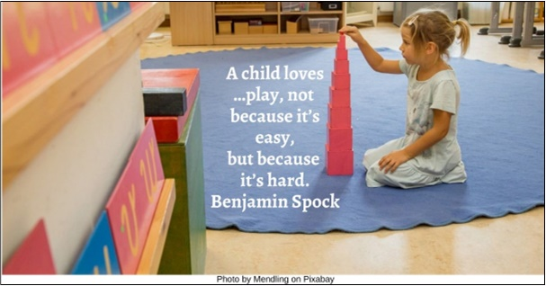

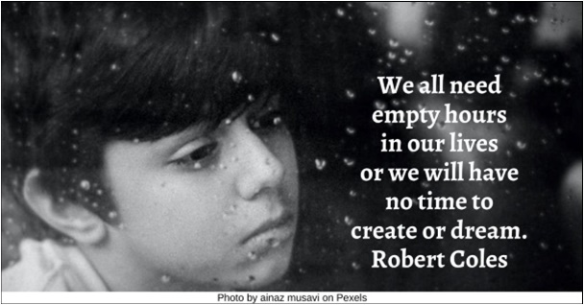

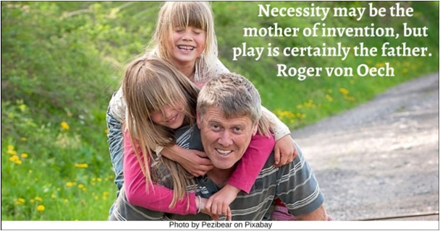

Food HRJ
Girl playing house HRJ
Having Fun HRJ
Inner Balance HRJ

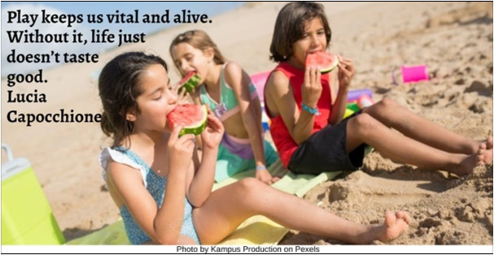

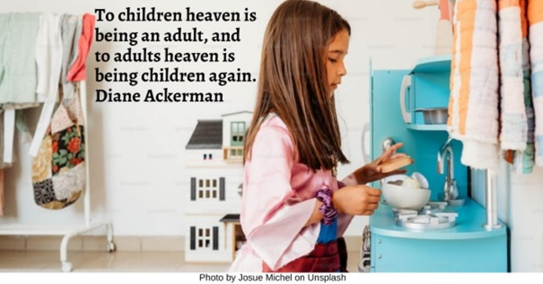

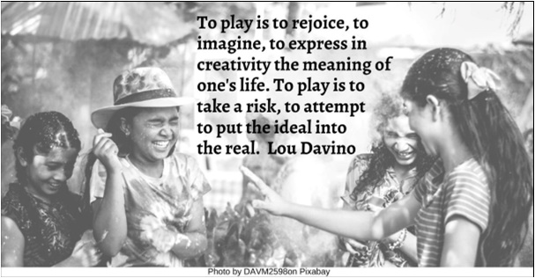

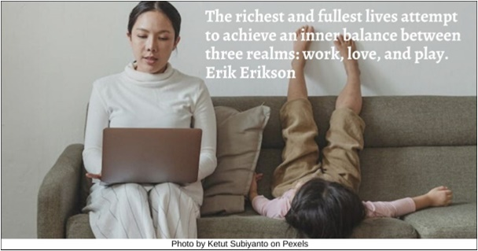

Jade HRJ
Lake HRJ
Lightening rod HRJ
Magic HRJ

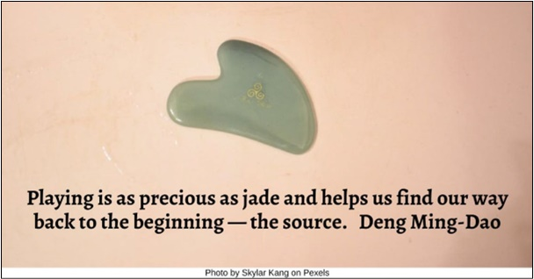

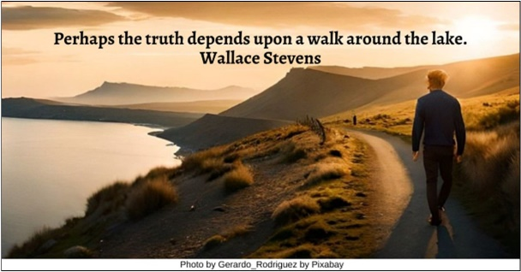

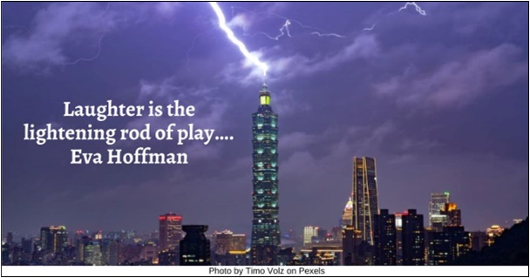

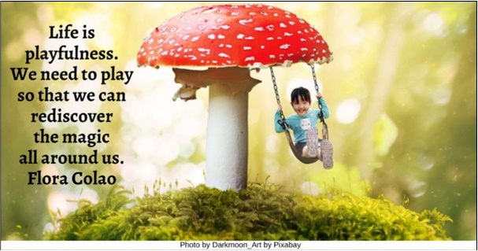

Messy HRJ
Music HRJ
Old Men Playing Dominoes HRJ
Play HRJ

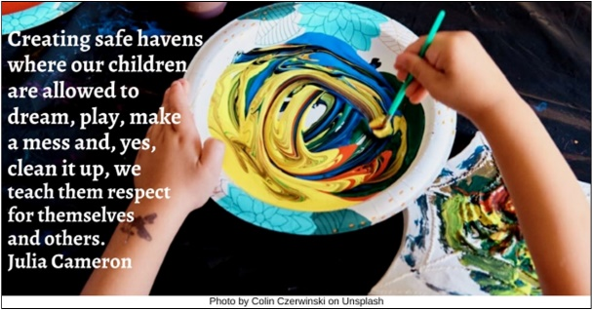

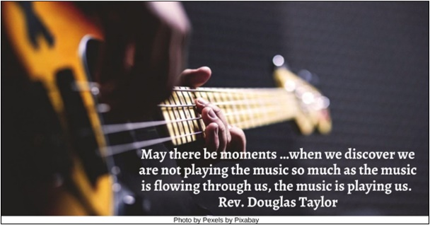

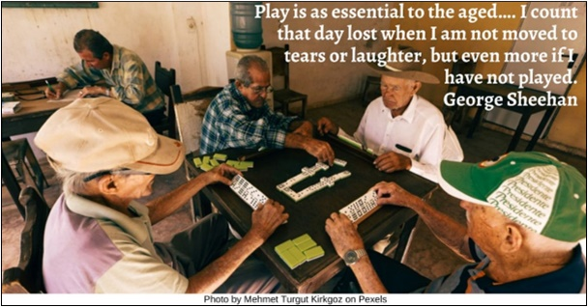

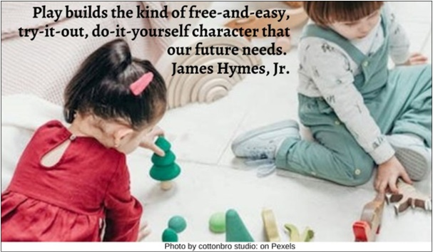

Playground HRJ
Playing with blocks HRJ
Sandcastle HRJ
Starry Night HRJ

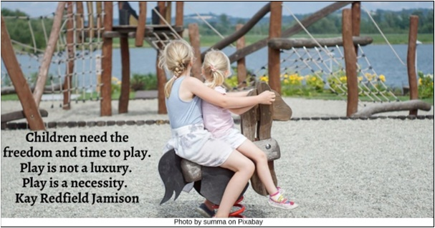

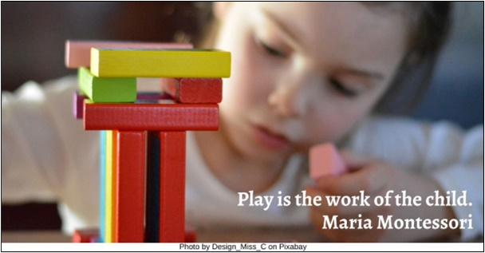

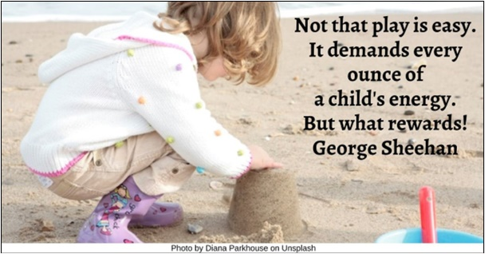

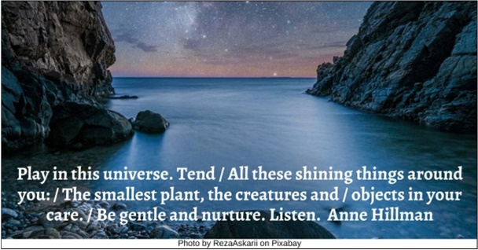

Talent HRJ
Tree of Life HR
Universe (Hubble) HRJ

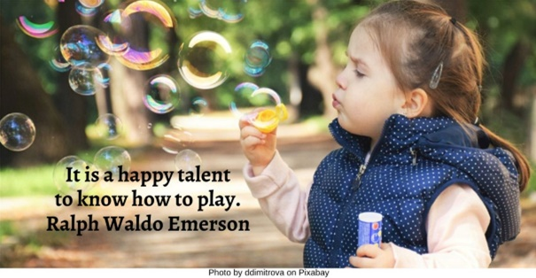

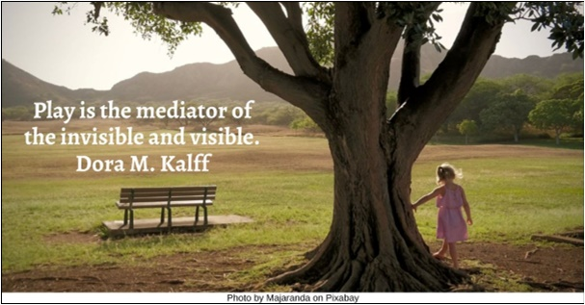

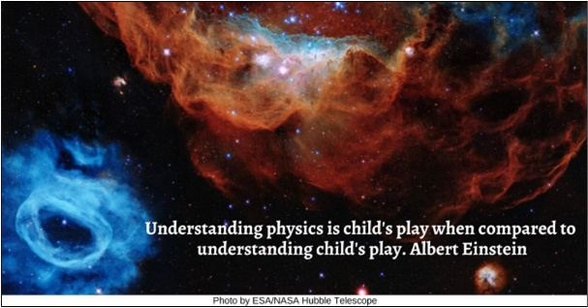

Text of Quotes
Adults Playing HRJ
Adults play too (or should). Julie Lythcott-Haims

Animals at Play HRJ
If animals play, this is …because play practices and so perfects the skills needed in adult life. Susanna Miller

Balance
Live a balanced life—learn some and think some and draw some and paint some and sing and dance and play and work every day some. Robert Fulghum

Beach
The true object of all human life is play. Gilbert K. Chesterton

Blowing Bubbles
Our brains are built to benefit from play no matter what our age. Theresa A. Kestly

Broken Toy
There is for many a poverty of play. D.W. Winnicott

Child Playing
Nor do you have to be holy to see God in all things. You only have to play as a child with an unselfish heart. Kathleen Norris

Children Looking at Clouds
When we play, we sense no limitations. …We immerse ourselves in the act of play. And we become free. Lenore Terr

Clown
The comic spirit masquerades in all things we say and do. We are each a clown…. James Hillman

Concentration
A child loves …play, not because it’s easy, but because it’s hard. Benjamin Spock
Daydreaming
We all need empty hours in our lives or we will have no time to create or dream. Robert Coles

Father Playing
Necessity may be the mother of invention, but play is certainly the father. Roger von Oech

Food
Play keeps us vital and alive. Without it, life just doesn’t taste good. Lucia Capocchione

Girl playing house HRJ
To children heaven is being an adult, and to adults heaven is being children again. Diane Ackerman

Having Fun
To play is to rejoice, to imagine, to express in creativity the meaning of one's life. To play is to take a risk, to attempt to put the ideal into the real. Lou Davino

Inner Balance
The richest and fullest lives attempt to achieve an inner balance between three realms: work, love, and play. Erik Erikson

Jade
Playing is as precious as jade and helps us find our way back to the beginning — the source. Deng Ming-Dao

Lake HRJ
Perhaps the truth depends upon a walk around the lake. Wallace Stevens

Lightening rod
Laughter is the lightening rod of play…. Eva Hoffman

Magic
Life is playfulness. We need to play so that we can rediscover the magic all around us. Flora Colao

Messy
Creating safe havens where our children are allowed to dream, play, make a mess and, yes, clean it up, we teach them respect for themselves and others. Julia Cameron

Music
May there be moments …when we discover we are not playing the music so much as the music is flowing through us, the music is playing us. Rev. Douglas Taylor

Old Men Playing Dominoes
Play is as essential to the aged…. I count that day lost when I am not moved to tears or laughter, but even more if I have not played. George Sheehan

Play
Play builds the kind of free-and-easy, try-it-out, do-it-yourself character that our future needs. James L. Hymes Jr

Playground HRJ
Children need the freedom and time to play. Play is not a luxury. Play is a necessity. Kay Redfield Jamison

Playing with blocks
Play is the work of the child. Maria Montessori

Sandcastle
Not that play is easy. It demands every ounce of a child's energy. But what rewards!
George Sheehan

Starry Night
Play in this universe. Tend / All these shining things around you: / The smallest plant, the creatures and / objects in your care. / Be gentle and nurture. Listen. Anne Hillman

Talent
It is a happy talent to know how to play. Ralph Waldo Emerson

Tree of Life
Play is the mediator of the invisible and visible. Dora M. Kalff

Universe (Hubble) HRJ
Understanding physics is child's play when compared to understanding child's play. Albert Einstein

